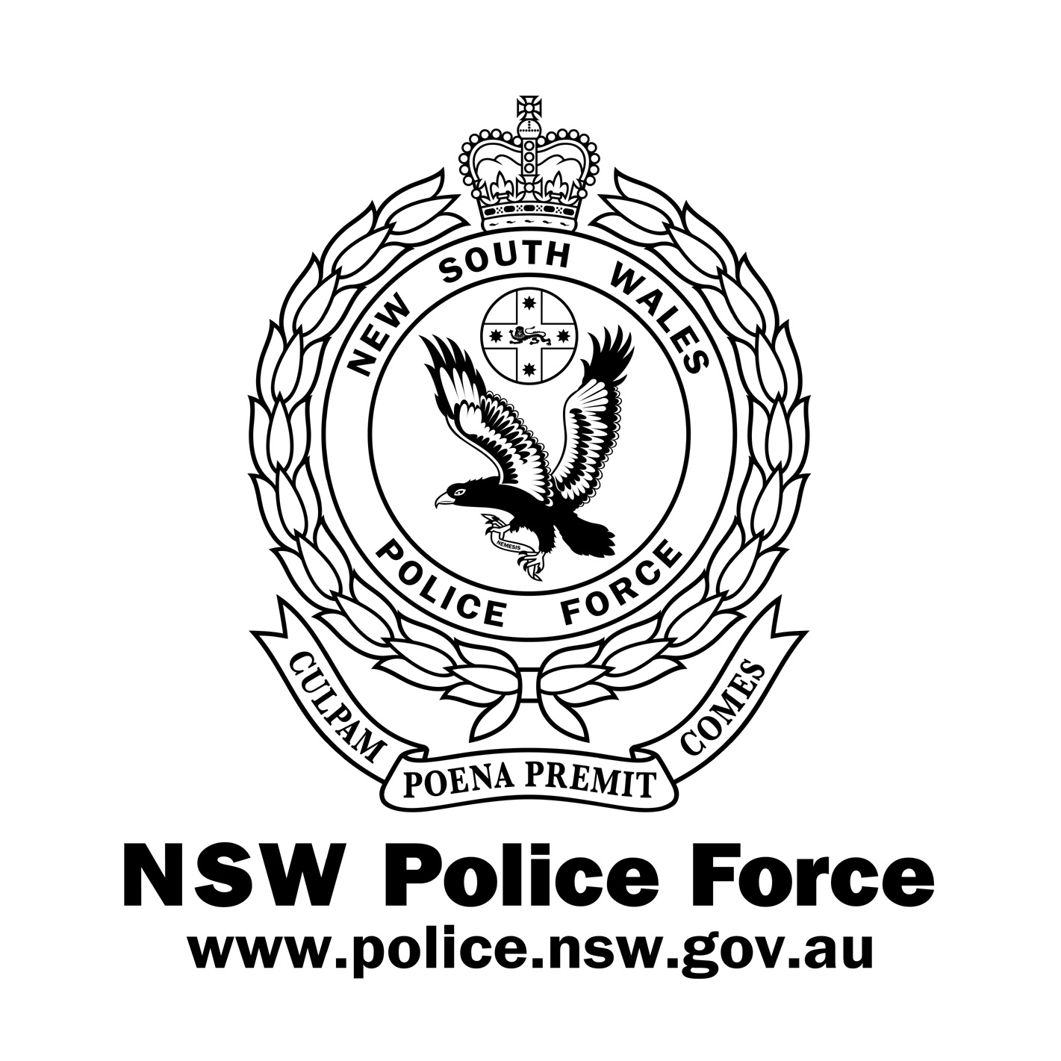
What’s New – 2014
NSW R Game Hunting Licence
The NSW Government disbanded the Game Council and temporarily suspended all licensed hunting in NSW State forests in July 2013.
The suspension of licensed hunting will be lifted on the 3 February 2014.
The Department of Primary Industries, Game Licensing Unit has been formed and will be responsible for the administration and issue of the new ‘R’ NSW Game Hunting Licence, which is replacing the old ‘R’ Game Council Licence.
All existing Game Council R licences are still recognised by the Firearms Registry as supporting an existing firearms licence with the genuine reason of Recreational Hunting and Vermin Control.
New firearms licence applications using the ‘R’ NSW Game Hunting Licence to support the genuine reason of Recreational Hunting and Vermin Control will be considered when the new ‘R’ licences are issued by the Game Licensing Unit of the Department of Primary Industries.
To find out more about the resumption of hunting in NSW State forests or the additional requirements to obtain permission to hunt and the requirements of the new ‘R’ NSW Game Hunting Licence, visit the NSW Department of Primary Industries.
You can contact the Game Licensing Unit on 02 63913750.

